Infosys Springboard Virtual Internship 6.0 Completion Report

Student Details

Batch Number: 4
Start date: 13th-October-2025
Name: Bhanu prasad babu Bellala
Internship Duration: 8 Weeks

1. Project Title
NeuroFleetX - AI-Driven Urban Mobility Optimization

2. Project Objective
The primary goal of the NeuroFleetX project was to create an advanced, AI-driven system for managing vehicle fleets and optimizing urban transportation. The NeuroFleetX project developed an AI-powered fleet management system to optimize urban mobility. It enabled real-time tracking of vehicle location, fuel, and engine health. Predictive analytics automated maintenance scheduling using risk scores. The system streamlined bookings, dispatching, and allocation with smart recommendations. Administrators were provided with dashboards for actionable insights. Overall, it enhanced operational efficiency and data-driven decision-making.

3. Project description in detail
NeuroFleetX is an AI-driven fleet optimization platform built using Spring Boot, MySQL, and React + Tailwind CSS. It helps transport organizations track vehicles, monitor real-time telemetry, automate dispatching, and improve overall fleet performance.
Approach & Implementation
Implemented secure authentication and role-based access using Spring Security + JWT.
Built a fleet inventory module for vehicle registration, status updates, and data management.
Collected and visualized real-time telemetry (GPS, fuel levels, engine temperature, mileage) through REST APIs.Added predictive maintenance with automated risk scoring based on threshold analytics.
Developed a booking & dispatcher module to manage assignments and recommend the best available vehicle.
Designed an admin dashboard featuring utilization analytics, maintenance alerts, and weekly mobility trends.
Technology Stack
Frontend: React, Tailwind CSS
Backend: Spring Boot, Spring Security, Hibernate, JWT
Database: MySQL
Version Control: Git, GitHub
Real-World Impact
NeuroFleetX provides practical value for logistics companies, cab services, municipal fleets, and transport operators by:
Reducing vehicle downtime using predictive maintenance.
Improving fuel efficiency through telemetry insights.
Automating dispatch and booking workflows.
Enhancing safety, reliability, and operational visibility.
Supporting smart city mobility initiatives.

4. Timeline Overview
Week | Activities Planned | Activities Completed
Week 1 | React fundamentals and design basic UI components | Created a responsive login page using React + Vite and integrated basic UI flow
Week 2 | Connect frontend structure and prepare for backend integration | Refined frontend layout, set up routes, and pushed completed login page to GitHub
Week 3 | Set up Spring Boot backend and configure security | Initialized backend project, implemented JWT authentication, created User/Role modules
Week 4 | Build fleet inventory module | Implemented vehicle registration, editing, and status tracking with database integration
Week 5 | Implement telemetry handling and REST APIs | Developed APIs for GPS, fuel, temperature, and mileage; linked telemetry to vehicles
Week 6 | Add predictive maintenance and booking workflow | Implemented risk scoring, alerts, booking lifecycle, and smart vehicle allocation
Week 7 | Build admin dashboard and integrate all modules | Added analytics graphs, alerts, activity widgets; completed end-to-end integration
Week 8 |  | Performed bug fixing, completed documentation, and prepared final presentation
  Testing, documentation, and final project demo

5a. Key Milestones
Milestone | Description | Date Achieved
Project Kickoff | Finalized requirements, architecture, and tech stack | 16th-Oct-2025
Prototype/First Draft |  | 24th-Oct-2025
  Built React login, JWT auth, and basic fleet inventory
Mid-Term Review | Implemented bookings, dispatcher flow, and enhanced telemetry | 20th-Nov-2025
Final Submission |  | 30th-Nov-2025
  Delivered full system with dashboard, analytics, and reports
Presentation | Demonstrated complete NeuroFleetX platform | 9th-Dec-2025

5b. Project execution details
The project was executed in a structured, phase-wise manner. After setting up the base architecture, core modules such as authentication and fleet inventory were completed first to ensure system stability. Telemetry integration was handled next, followed by predictive maintenance and booking automation. The final stages focused on dashboards, analytics, optimization, and testing. GitHub was used for version control, and Postman for continuous API validation.
The execution emphasized clean code practices, a 3-layer architecture (Controller–Service–Repository), consistent testing, and UI responsiveness. All modules were integrated seamlessly to form a professional fleet management solution.

6. Snapshots / Screenshots

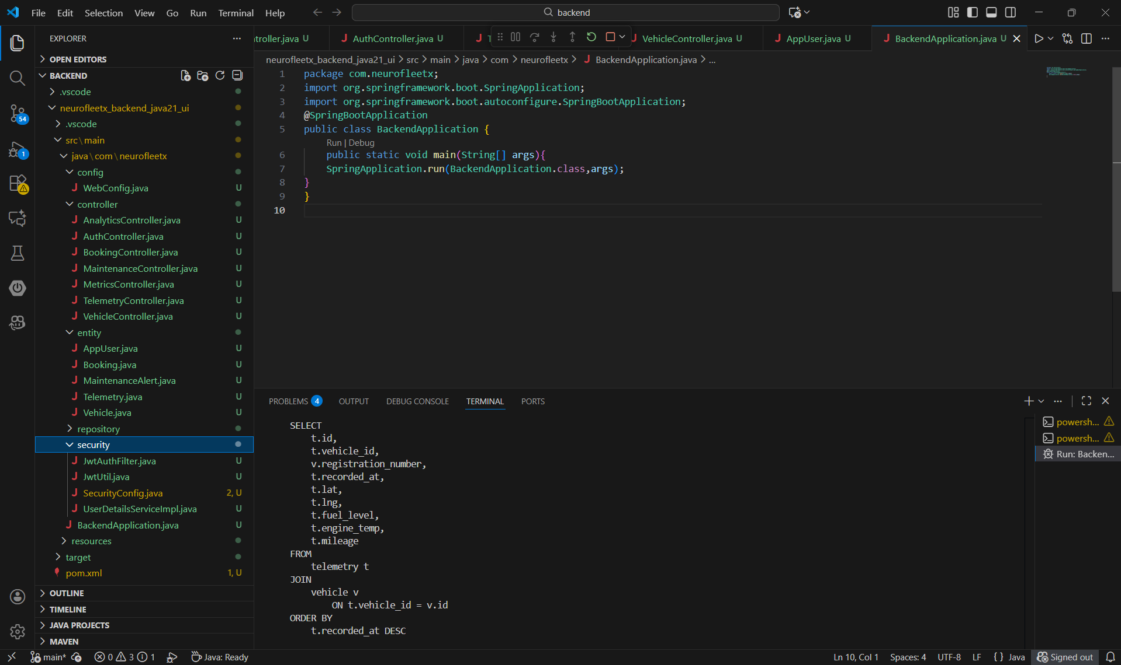

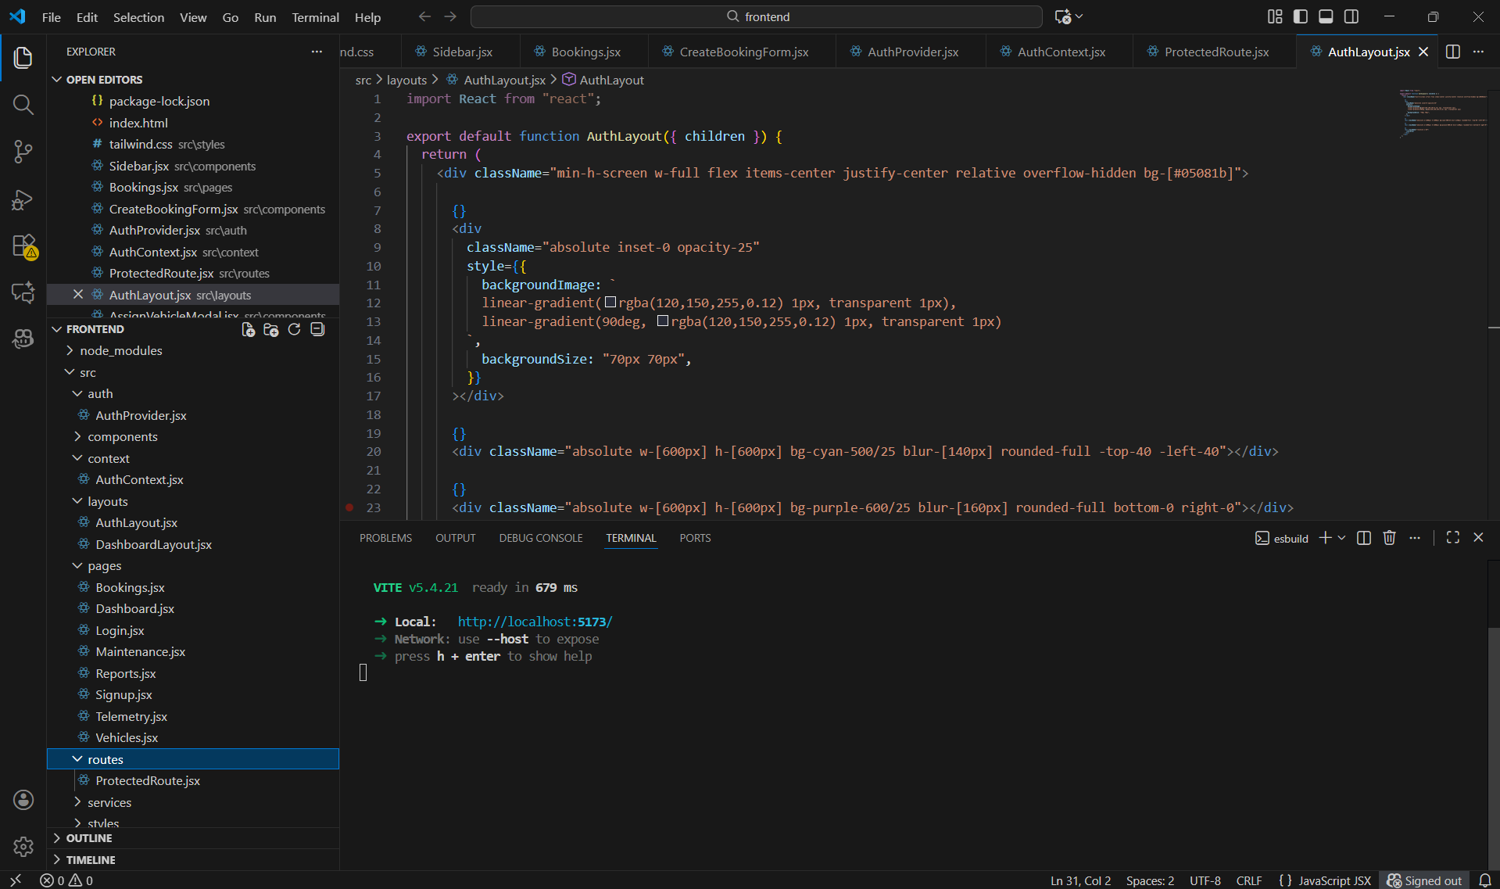
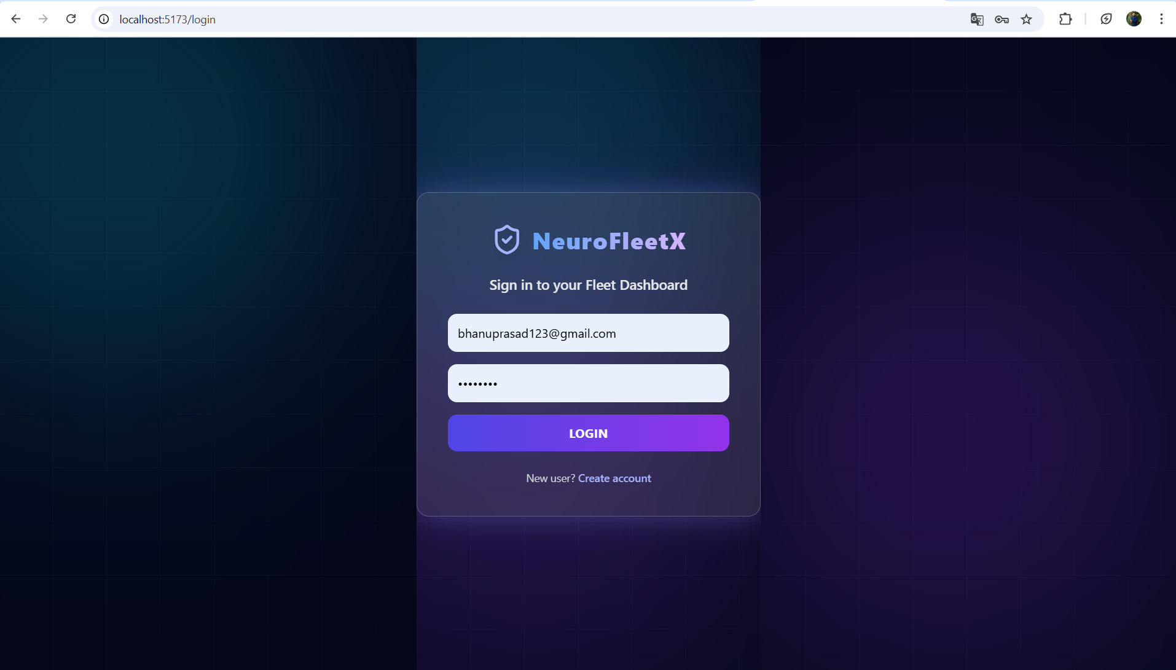
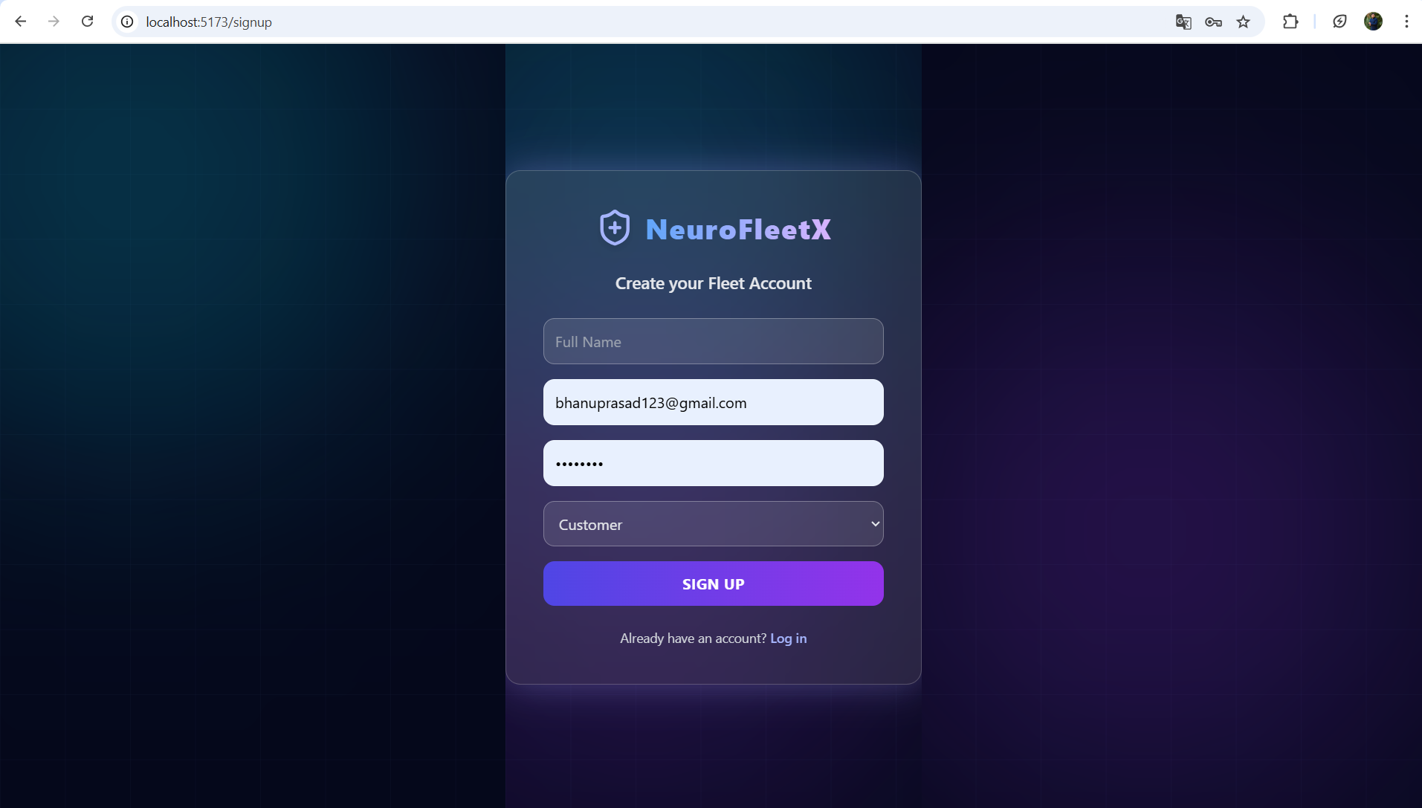
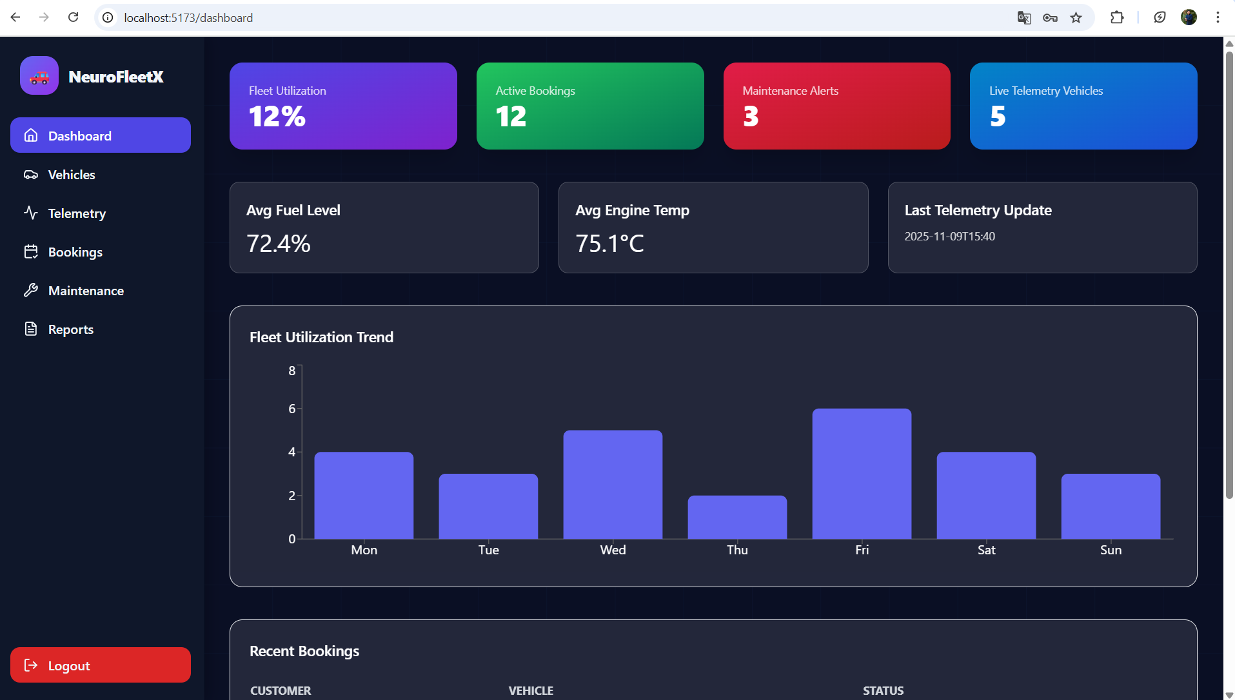
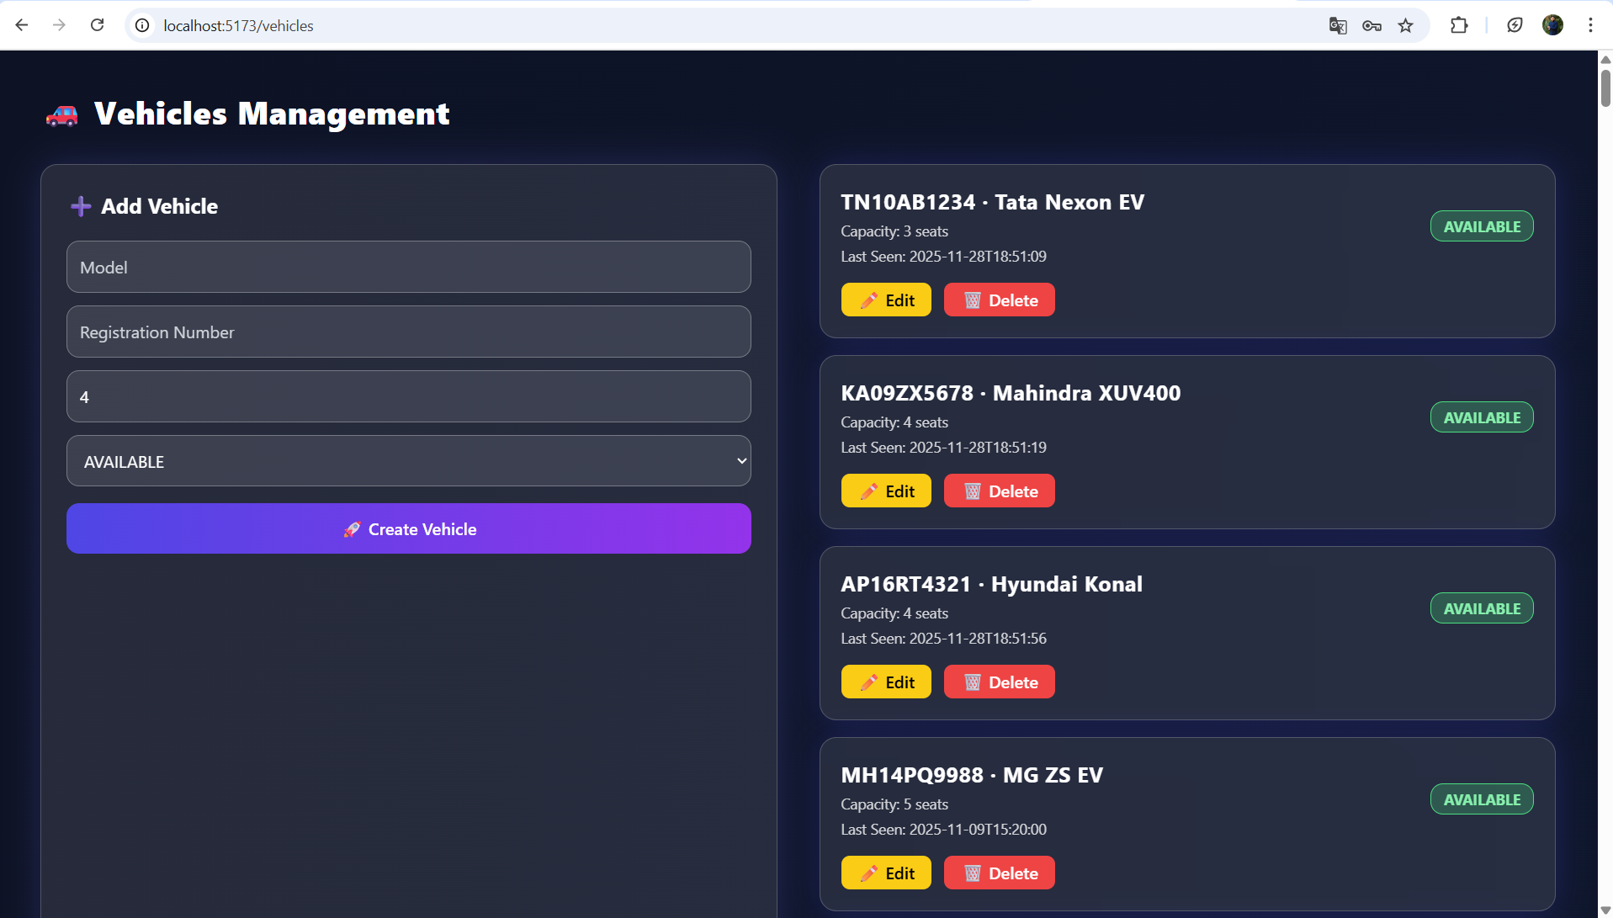
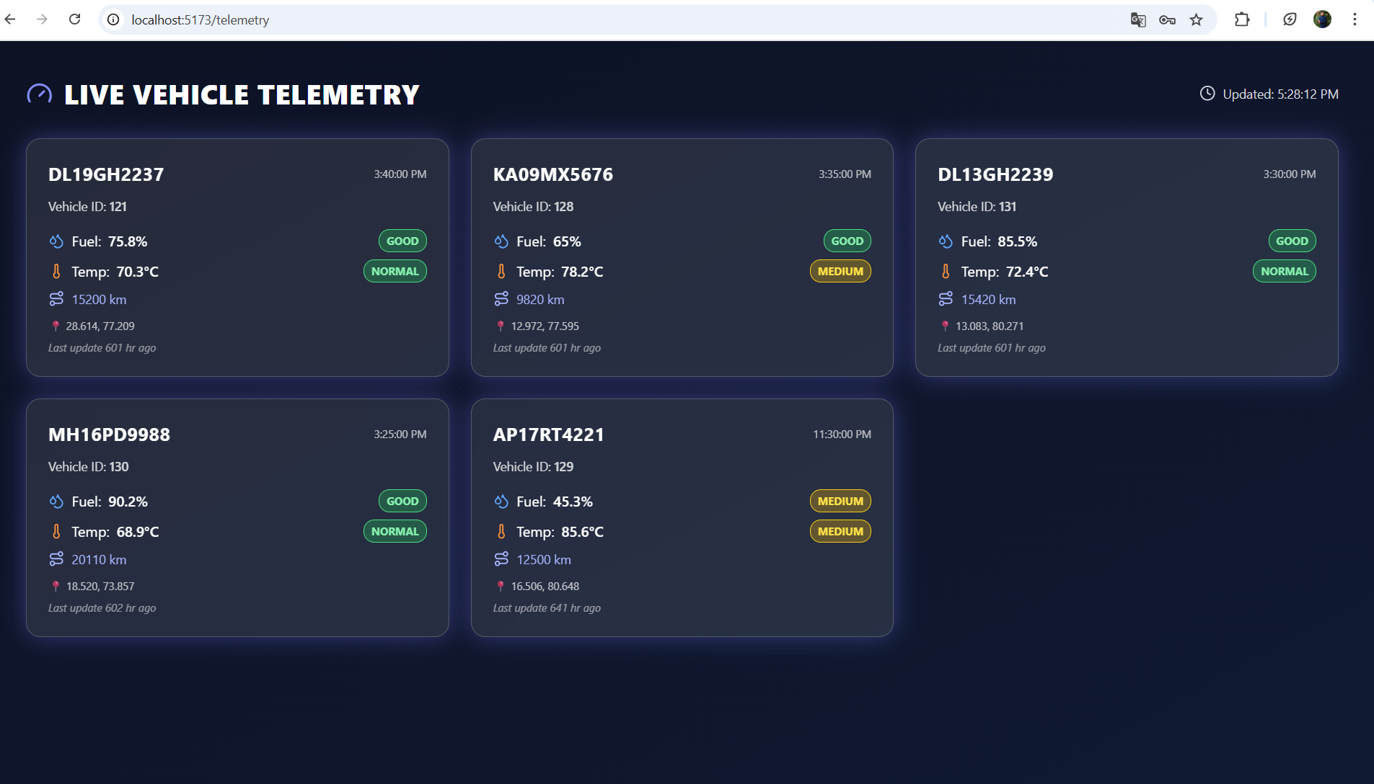
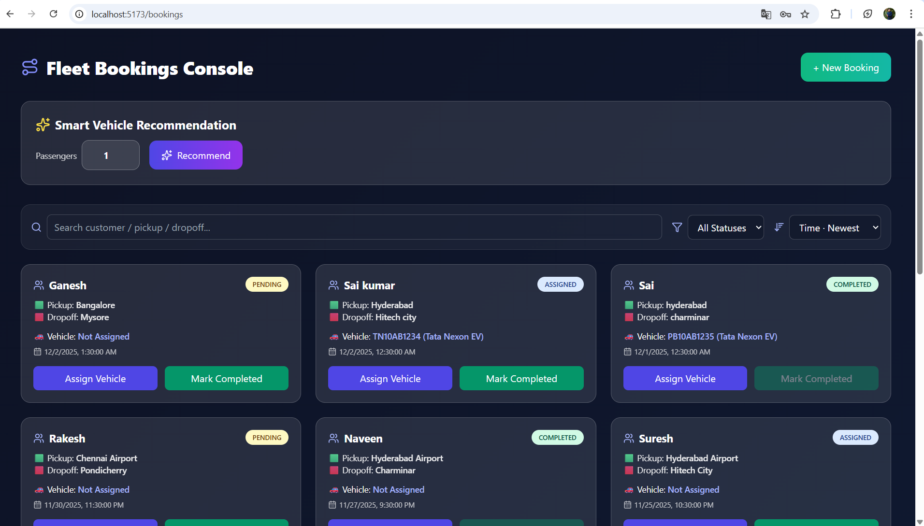
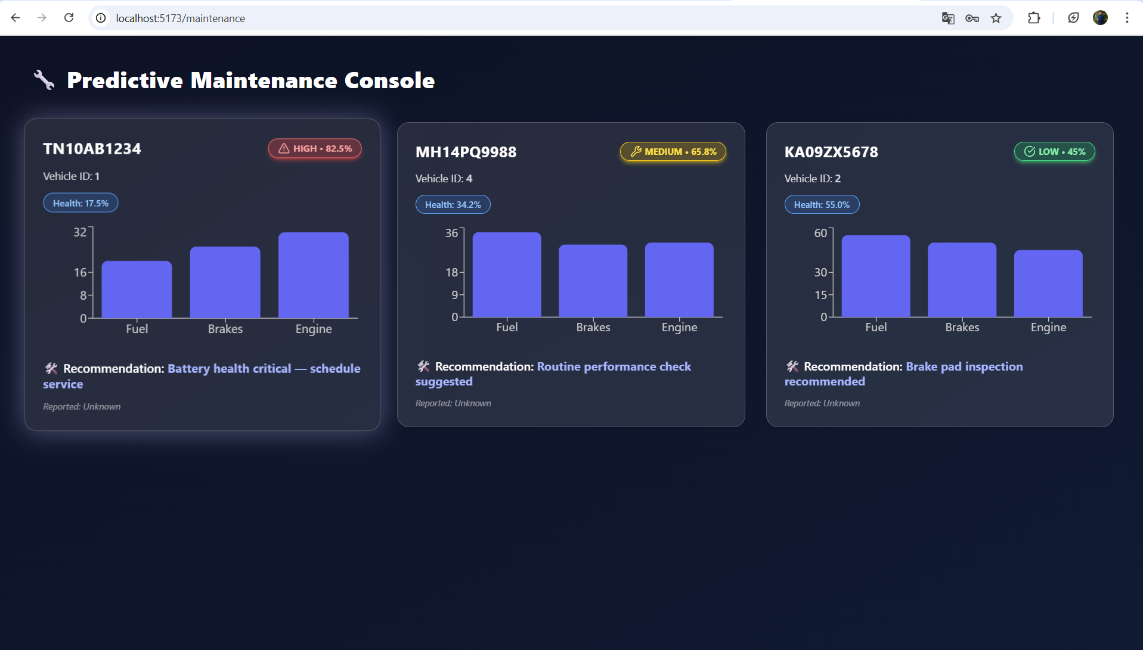
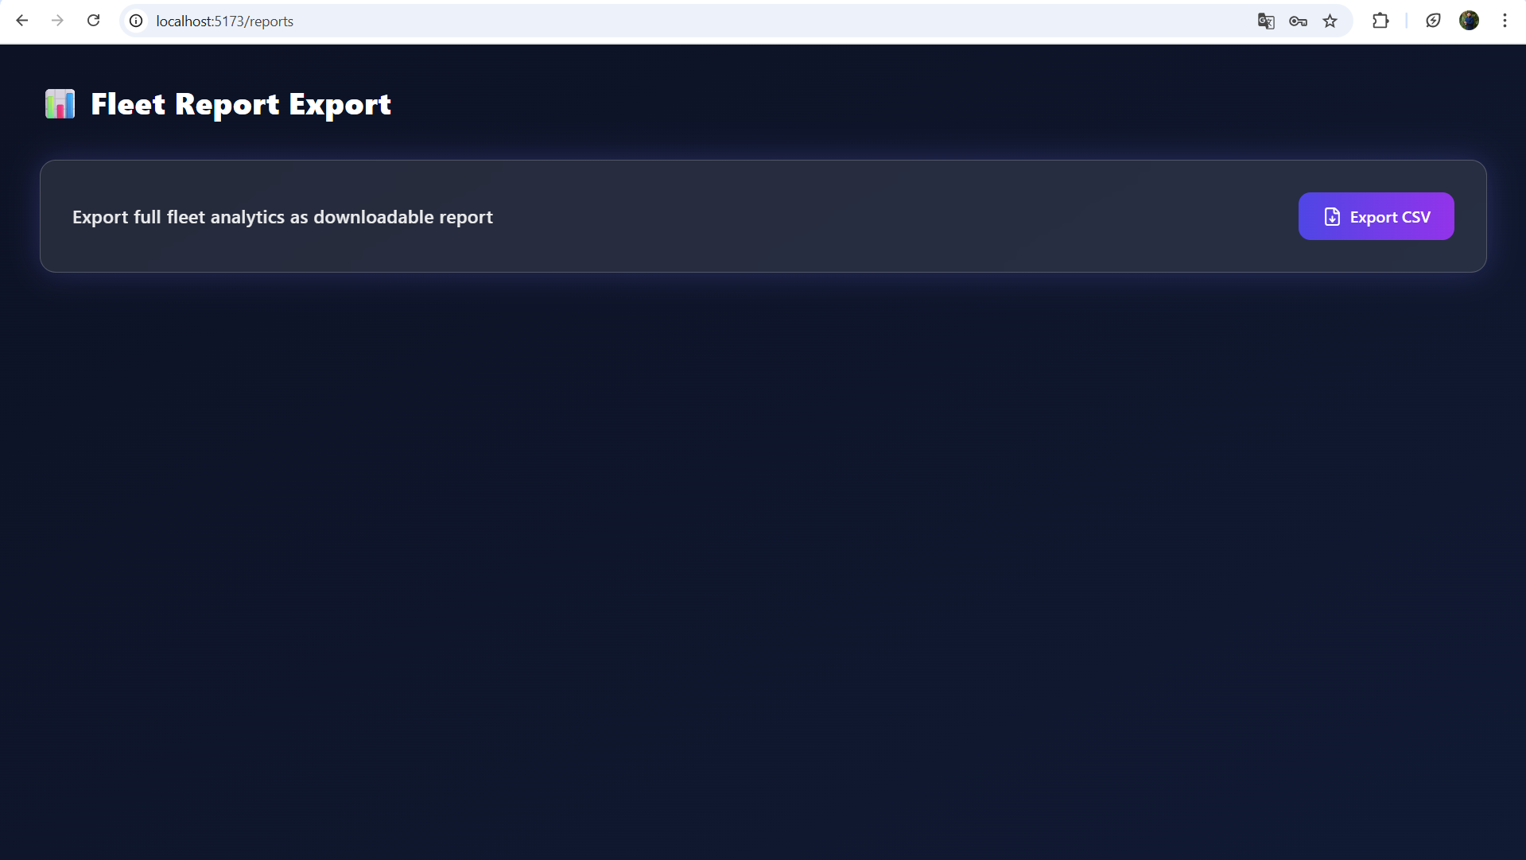

7. Challenges Faced
The NeuroFleetX project faced several challenges due to its full-stack architecture using React, Spring Boot, and MySQL. Managing real-time telemetry data, asynchronous API calls, and consistent vehicle updates required optimized backend design and efficient state management. Building smooth GPS, fuel, temperature, and mileage data flows demanded high-performance REST APIs. Developing the predictive maintenance engine was complex, involving accurate risk scoring, threshold tuning, and validation across multiple vehicle conditions. Implementing JWT-based role-based access control for Admin, Dispatcher, and Users added additional security challenges. On the frontend, ensuring live dashboard updates, integrating charts and alerts, and maintaining UI performance were major tasks. As modules expanded, scalability, API optimization, and seamless module integration also became important challenges. Testing telemetry, booking workflows, and predictive logic required multiple debugging cycles to ensure reliability. Through continuous refinement, documentation study, and iterative testing, all issues were resolved, resulting in a stable and fully integrated platform.

8. Learnings & Skills Acquired
By developing NeuroFleetX, I strengthened my full-stack development skills through the integration of React for building responsive user interfaces and Spring Boot for developing secure backend services. I worked extensively with MySQL for structured data management, optimized queries, and maintaining real-time consistency across telemetry, bookings, and maintenance modules. On the backend, I gained hands-on experience in building RESTful APIs, implementing JWT-based authentication, configuring Spring Security, and applying JPA/Hibernate for data access. The project also helped me refine my skills in API testing using Postman, debugging CORS issues, and handling asynchronous data flow between modules. On the frontend, I worked with React, React Router, Axios, and TailwindCSS to create dynamic, efficient dashboards with charts, alerts, and live data updates. I also improved UI performance and smooth transitions within the application. Version control and project workflow were strengthened through regular use of Git and GitHub, along with build tools like npm and Maven. Overall, the project enhanced my understanding of predictive analytics, real-time fleet monitoring, and the importance of building scalable, user-centric, and reliable software systems.

9. Testimonials from team
Working on NeuroFleetX allowed me to contribute to a real-time, full-stack fleet management system. I was impressed with the strong understanding demonstrated in React, Spring Boot, and MySQL, along with the ability to implement telemetry handling, predictive maintenance, and secure role-based access. The dedication to integrating complex modules dashboard, bookings, dispatcher, and analytics showed excellent problem-solving and consistency. This project reflects professional-level development skills and readiness for real-world software engineering challenges.

10. Conclusion
The NeuroFleetX project successfully demonstrated how a modern full-stack architecture can streamline fleet operations through real-time telemetry, predictive maintenance, and automated booking workflows. By integrating React on the frontend with a secure Spring Boot backend and MySQL database, the system achieved reliability, scalability, and efficient data handling across all user roles.
Despite challenges such as real-time data synchronization, security configuration, and module integration, the project significantly strengthened full-stack development skills and deepened understanding of building production-ready applications. Features like the live dashboard, dispatcher automation, risk-scoring engine, and analytics modules showcase the system’s ability to support data-driven decision-making for fleet management.
Overall, NeuroFleetX stands as a robust and practical solution that enhances operational efficiency, improves vehicle monitoring, and moves toward smarter, technology-enabled fleet management for modern transportation environments.

11. Acknowledgements
I would like to express my heartfelt gratitude to Infosys for providing me with the opportunity to work on the NeuroFleetX project as part of my internship. This experience has been invaluable in enhancing my technical knowledge, professional skills, and understanding of real-world software development practices.I extend my sincere thanks to my mentor, Mr. Senthil, for his continuous guidance, encouragement, and support throughout the project. His expertise, constructive feedback, and insightful suggestions played a crucial role in shaping the success of this work. I am also thankful to my teammates and everyone at Infosys who contributed directly or indirectly to the successful completion of this project. This journey has been a truly enriching and memorable learning experience.

